5.2 Project: Final Submission
Christopher Crayton
ECPI University
SDC330L: Advanced Object-oriented Programming Using Java LAB
Dr. Helio de Castro
August 28, 2026

5.2 Project: Final Submission
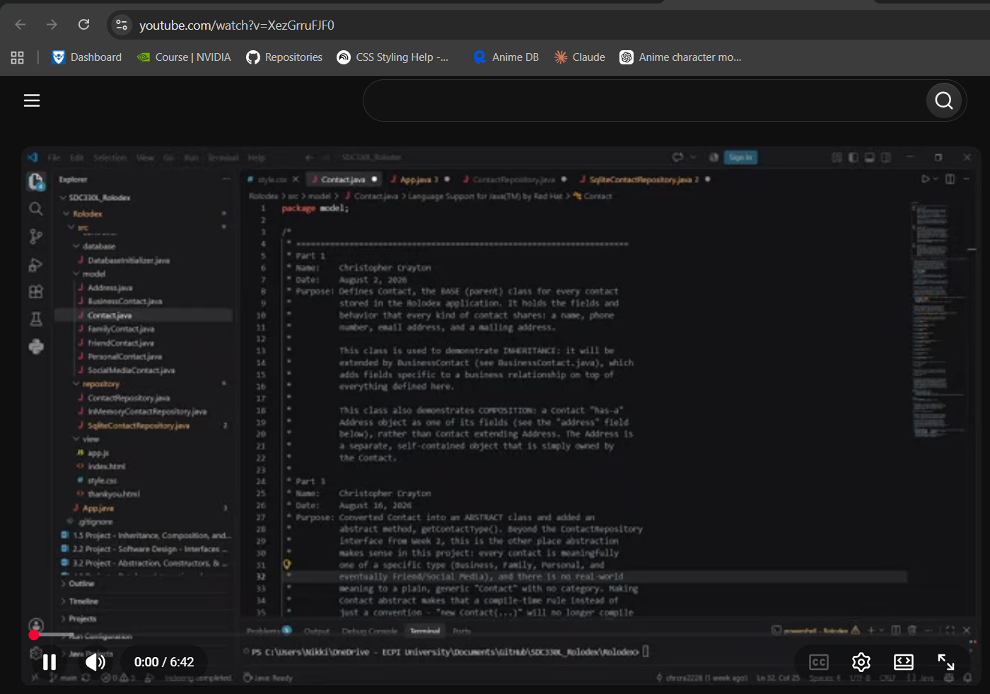
YouTube Link for Video Demonstration: https://youtu.be/XezGrruFJF0

GitHub Repository Link: https://github.com/chrcra2226/Rolodex.git

